UNITED STATES
SECURITIES AND EXCHANGE COMMISSION
WASHINGTON, D.C. 20549
FORM 6-K
REPORT OF FOREIGN PRIVATE ISSUER
PURSUANT TO RULE 13A-16 OR 15D-16 UNDER
THE SECURITIES EXCHANGE ACT OF 1934
For the month of September 2026
Commission File Number: 001-40010
Pharvaris N.V.
(Translation of registrant’s name into English)
Emmy Noetherweg 2

2333 BK Leiden

The Netherlands
(Address of principal executive office)

Indicate by check mark whether the registrant files or will file annual reports under cover of Form 20-F or Form 40-F.
Form 20-F ☒ Form 40-F ☐

Indicate by check mark if the registrant is submitting the Form 6-K in paper as permitted by Regulation S-T Rule 101(b)(1): ☐

Note: Regulation S-T Rule 101(b)(1) only permits the submission in paper of a Form 6-K if submitted solely to provide an attached annual report to security holders.

Indicate by check mark if the registrant is submitting the Form 6-K in paper as permitted by Regulation S-T Rule 101(b)(7): ☐

Note: Regulation S-T Rule 101(b)(7) only permits the submission in paper of a Form 6-K if submitted to furnish a report or other document that the registrant foreign private issuer must furnish and make public under the laws of the jurisdiction in which the registrant is incorporated, domiciled or legally organized (the registrant’s “home country”), or under the rules of the home country exchange on which the registrant’s securities are traded, as long as the report or other document is not a press release, is not required to be and has not been distributed to the registrant’s security holders, and, if discussing a material event, has already been the subject of a Form 6-K submission or other Commission filing on EDGAR.

PHARVARIS N.V.

On September 8, 2026, Pharvaris N.V. issued a press release announcing positive topline data from CHAPTER-3 pivotal study of deucrictibant XR for prophylaxis of HAE attacks. A copy of the press release is attached hereto as Exhibit 99.1. Exhibit 99.1 shall not be deemed “filed” for purposes of Section 18 of the Securities Exchange Act of 1934 (the “Exchange Act”) or otherwise subject to the liabilities of that section, nor shall it be deemed incorporated by reference in any filing under the Securities Act of 1933, as amended, or the Exchange Act.

EXHIBIT INDEX
Exhibit  No. |  | Description
99.1 |  | Press Release, dated September 8, 2026.

SIGNATURES

Pursuant to the requirements of the Securities Exchange Act of 1934, the registrant has duly caused this report to be signed on its behalf by the undersigned, thereunto duly authorized.
 | PHARVARIS N.V.
Date: September 8, 2026 | By: | /s/ Berndt Modig
 | Name: | Berndt Modig
 | Title: | Chief Executive Officer


Exhibit 99.1
Pharvaris Announces Positive Topline Data from CHAPTER-3 Pivotal Study of Deucrictibant XR for Prophylaxis of HAE Attacks

•
Primary endpoint met: 83% attack rate reduction versus placebo (p<0.0001) in the first and only prophylaxis Phase 3 study in all three types of HAE
•
87% attack rate reduction versus placebo observed in people with HAE Type 1 or Type 2
•
All secondary efficacy endpoints met with statistical significance
•
Well-tolerated safety profile of deucrictibant XR demonstrated
•
Conference call and webcast today at 8:00 a.m. EDT

ZUG, Switzerland, September 8, 2026 – Pharvaris (Nasdaq: PHVS), a late-stage biopharmaceutical company developing novel, oral bradykinin B2 receptor antagonists to help address unmet needs of those living with bradykinin-mediated angioedema (AE-BK), such as hereditary angioedema (HAE) and acquired angioedema due to C1 inhibitor deficiency (AAE-C1INH), today announced statistically significant and clinically meaningful topline results of the CHAPTER-3 pivotal Phase 3 study evaluating deucrictibant extended-release (XR) tablet for the prevention of HAE attacks. The primary endpoint and all secondary efficacy endpoints were met with statistical significance. Data from the CHAPTER-3 study will serve as the basis for marketing authorization applications, which are planned to be submitted starting in the first half of 2027.

CHAPTER-3 Study Design and Results
The CHAPTER-3 (NCT06669754) global Phase 3, double-blind, placebo-controlled study evaluated orally administered deucrictibant XR tablet (40 mg, once daily) for the prevention of attacks in adolescents and adults with HAE. CHAPTER-3 is the first and only prophylaxis Phase 3 study to evaluate all three types of HAE, including people with HAE type 1, HAE type 2, or HAE with normal C1 inhibitor. The study randomized 85 participants from 21 countries in a 2:1 ratio to deucrictibant XR (N=55) or placebo (N=30) for 24 weeks of treatment.

Treatment with deucrictibant XR in participants with all types of HAE reduced the mean monthly attack rate by 83% (p<0.0001). Further analysis in the 80 participants with HAE Type 1 or Type 2 showed that the mean monthly attack rate was 87% lower in the deucrictibant XR group compared to placebo. Primary endpoint results were consistent across subgroups. All secondary efficacy endpoints, assessed sequentially under a multiplicity-control procedure, were also met with statistical significance. In

CHAPTER-3, administration of deucrictibant XR resulted in early-onset protection within the first week, which was then sustained through the 24 weeks of study treatment. Robust reductions in attack rate from baseline and increases in the percentage of attack-free participants were observed in the deucrictibant-treated group.
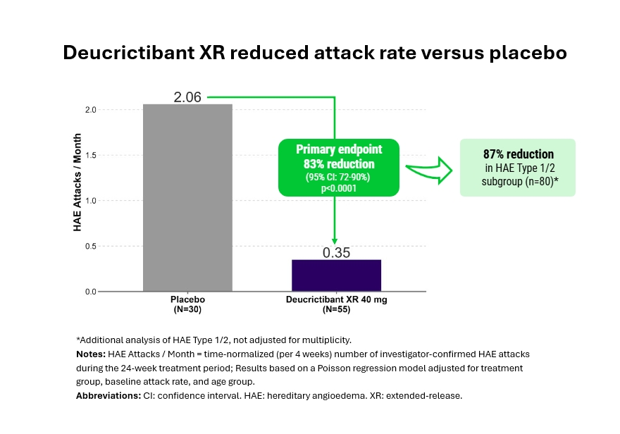

In CHAPTER-3, deucrictibant XR was well tolerated with most treatment-emergent adverse events being mild or moderate. There were no treatment-related serious adverse events reported. One participant in each group discontinued treatment due to an adverse event.

Marc A. Riedl, M.D., M.S., Professor of Medicine, Clinical Director of the U.S. Hereditary Angioedema Association (HAEA) Angioedema Center at the University of California San Diego (UCSD), and principal investigator in the CHAPTER-3 study, commented, “Alongside the RAPIDe-3 data in the on-demand setting, these CHAPTER-3 results further confirm the value of targeting the bradykinin B2 receptor for both the prevention and treatment of attacks across all types of HAE. People living with HAE are seeking novel treatment options that offer improved disease control and health-related quality of life, with reduced treatment burden. If approved, the efficacy, tolerability, and convenient oral administration

position deucrictibant XR as a potential important addition to HAE clinical practice, supporting individualized treatment strategies designed around shared decision making.”

Peng Lu, M.D., Ph.D., President of Pharvaris, stated, “People living with HAE have been waiting for a well-tolerated oral therapy with injectable-like efficacy; we believe deucrictibant XR can help address this unmet need. CHAPTER-3 showed statistically significant reductions in attack frequency, characterized by early and sustained protection, clinically meaningful improvements in health-related quality of life, and better HAE control. The successful study completion would not have been possible without the incredible contributions of the clinical study participants and their caregivers, the site investigators and staff, the HAE community, our study partners, and the Pharvaris team, to whom we are sincerely thankful.”

Dr. Lu continued, “With the ongoing regulatory review of the NDA of deucrictibant IR for on-demand treatment of HAE attacks and the planned submission of an NDA for deucrictibant XR for prevention of bradykinin-mediated angioedema attacks, we are focused on commercial preparation for two potential launches. Pharvaris aims to set a new standard in stakeholder engagement by delivering a best-in-class experience for the community, powered by our expertise and integrated capabilities across the deucrictibant portfolio.”

Berndt Modig, Chief Executive Officer of Pharvaris, added, “Pharvaris was founded on the vision of elevating the standard of care in HAE. Today represents a landmark moment for the company and the community as a whole: deucrictibant could be the first and only oral therapy to offer injectable-like efficacy and a well-tolerated profile in on-demand treatment and prophylaxis with our two unique formulations. Pharvaris now plans to redefine disease management by uniting on-demand treatment and long-term prophylaxis within a single therapeutic franchise. This encourages us to further leverage our deep scientific expertise to bring novel therapies to those living with bradykinin-mediated diseases with unmet medical needs, beyond angioedema.”

Pharvaris plans to present additional efficacy, safety, and participant experience data from the CHAPTER-3 study at upcoming medical congresses.

The CHAPTER-4 open-label long-term extension study of deucrictibant XR for the prophylaxis of HAE attacks is ongoing.

Topline data from Part 1 of CREAATE (NCT07266805), a global, pivotal Phase 3 study evaluating orally-administered deucrictibant XR for the prevention of AAE-C1INH attacks, are anticipated in the first quarter of 2027. Enrollment in CREAATE is ongoing and progressing as planned.

Pharvaris plans to submit a New Drug Application to the U.S. Food and Drug Administration for the prophylaxis of bradykinin-mediated angioedema attacks in the first half of 2027.

Conference Call
Pharvaris will host a live conference call and webcast to discuss the CHAPTER-3 study topline data in greater detail at 8:00 a.m. EDT today via a live webcast; presentation slides may be accessed on the “Events and Presentations” page of the Pharvaris investor relations website. Participants interested in asking a verbal question during the Q&A may do so in the live conference call. An archived replay will also be available on the website for 90 days following the event.

About Deucrictibant
Deucrictibant is a novel, potent, orally bioavailable small-molecule bradykinin B2 receptor antagonist currently in clinical development. Deucrictibant is being investigated for its potential to prevent the occurrence of bradykinin-mediated angioedema attacks and to treat the manifestations of attacks if/when they occur by inhibiting bradykinin signaling through the bradykinin B2 receptor. Pharvaris is developing two formulations of deucrictibant for oral administration: an extended-release tablet to enable sustained absorption and efficacy as prophylactic treatment, and an immediate-release capsule to enable rapid onset of activity for on-demand treatment. Deucrictibant has been granted orphan drug designation for the treatment of bradykinin-mediated angioedema by the U.S. Food and Drug Administration, the European Commission, and Swissmedic.

About Pharvaris
Pharvaris is a late-stage biopharmaceutical company developing novel, oral bradykinin B2 receptor antagonists to help address unmet needs in bradykinin-mediated conditions, including all types of bradykinin-mediated angioedema. Pharvaris’ aspiration is to offer therapies with injectable-like efficacy, a well-tolerated profile, and the convenience of oral administration to prevent and treat bradykinin-mediated angioedema attacks. By delivering on this aspiration, Pharvaris aims to provide a new standard of care in bradykinin-mediated angioedema. For more information, visit https://pharvaris.com/.

Forward Looking Statements
This press release contains certain forward-looking statements that involve substantial risks and uncertainties. All statements contained in this press release that do not relate to matters of historical fact should be considered forward-looking statements, including, without limitation, statements relating to our future plans, studies and trials, and any statements containing the words “believe,” “anticipate,” “expect,” “estimate,” “may,” “could,” “should,” “would,” “will” and similar expressions. These forward-looking statements are based on management’s current expectations, are neither promises nor guarantees, and involve known and unknown risks, uncertainties and other important factors that may cause Pharvaris’ actual results, performance or achievements to be materially different from its expectations expressed or implied by the forward-looking statements. Such risks include but are not limited to the following: uncertainty in the outcome of our interactions with regulatory authorities, including the FDA; the expected timing, progress, or success of our clinical development programs, especially for deucrictibant immediate-release capsules and deucrictibant extended-release tablets, which are in late-stage global clinical trials; the outcome of regulatory approvals, including the outcome of our NDA and MAA for the on-demand treatment of acute attacks of HAE; our ability to replicate the efficacy and safety demonstrated in the RAPIDe-1, RAPIDe-2, RAPIDe-3, CHAPTER-1, and CHAPTER-3 Phase 2 and Phase 3 studies in ongoing and future nonclinical studies and clinical trials, such as CREAATE; risks arising from epidemic diseases, which may adversely impact our business, nonclinical studies, and clinical trials; our ability to potentially use deucrictibant for alternative purposes, for example to treat C1-INH deficiency (AAE-C1INH); the value of our ordinary shares; the timing, costs and other limitations involved in obtaining regulatory approval for our product candidates, or any other product candidate that we may develop in the future; our ability to establish commercial capabilities or enter into agreements with third parties to market, sell, and distribute our product candidates; our ability to compete in the pharmaceutical industry, including with respect to existing therapies, emerging potentially competitive therapies and with competitive generic products; our ability to market, commercialize and achieve market acceptance for our product candidates; our ability to produce sufficient amounts of drug product candidates for commercialization; our ability to raise capital when needed and on acceptable terms; regulatory developments in the United States, the European Union and other jurisdictions; our ability to protect our intellectual property and know-how and operate our business without infringing the intellectual property rights or regulatory exclusivity of others; our ability to manage negative consequences from changes in applicable laws and regulations, including tax laws (including the Biosecure Act), our ability to maintain an effective system of internal control over financial reporting; changes and uncertainty in general market conditions; disruptions at the FDA and other agencies; changes and uncertainty in general market, political and economic conditions, including as a result of inflation and

geopolitical conflicts; changes in regulations and customs, tariffs and trade barriers; and the other factors described under the headings “Cautionary Statement Regarding Forward-Looking Statements” and “Item 3. Key Information—D. Risk Factors” in our Annual Report on Form 20-F and other periodic filings with the U.S. Securities and Exchange Commission. These and other important factors could cause actual results to differ materially from those indicated by the forward-looking statements made in this press release. Any such forward-looking statements represent management’s estimates as of the date of this press release. New risks and uncertainties may emerge from time to time, and it is not possible to predict all risks and uncertainties. While Pharvaris may elect to update such forward-looking statements at some point in the future, Pharvaris disclaims any obligation to do so, even if subsequent events cause its views to change. These forward-looking statements should not be relied upon as representing Pharvaris’ views as of any date subsequent to the date of this press release.

Contact
Maggie Beller
Vice President, Head of Corporate and Investor Communications
maggie.beller@pharvaris.com

